Udemy logger – Code Challengue

This is a short explanation about the code, to make easy to understand the rest of the files attached.

I was using separate modules to Split and win in the challenge, so once they were created would be easier to put altogether the pieces.

So you can find 6 udemyX.py files, where X is a value from 1 to 6 according the questions.

There is a file called udemyparse.py with the global app.

Then I tried to consolidate everything in one, the challenge there, the problems with the context and overlapping modifiers / params in the command.

Some libraries that I was using before now they were deprecated so I was changing some things ….

Here some screnshots.

I was using a Windows environment.

Main help, udemyparse.py --help or udemyparse.py - h

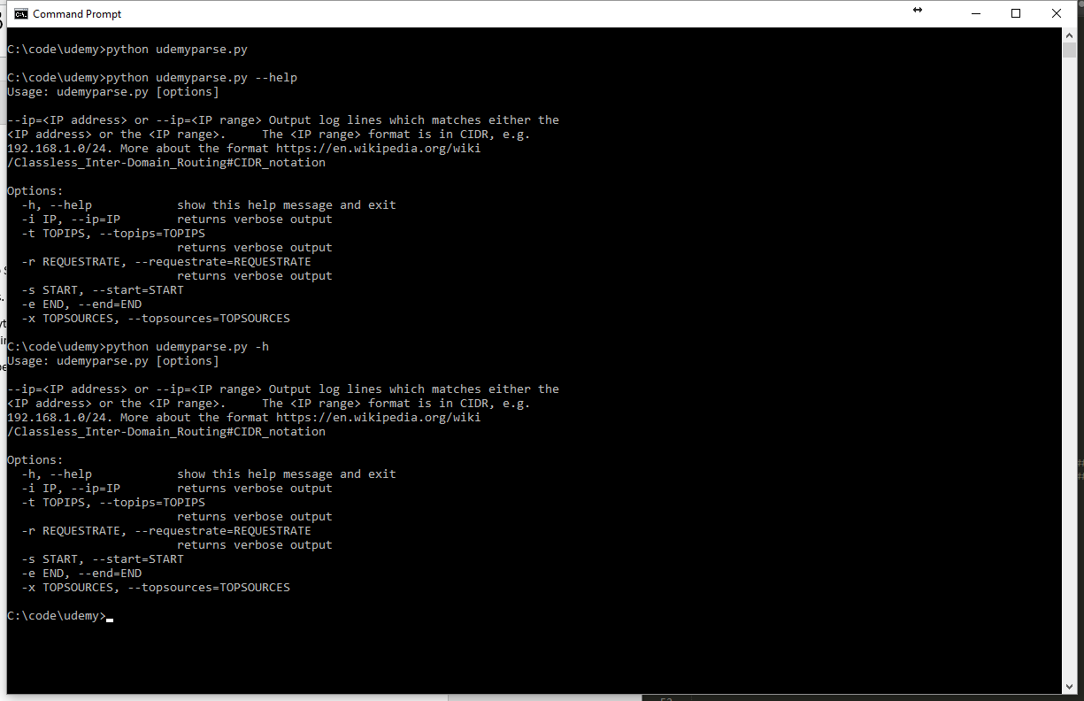

First question udemyparse.py –ip

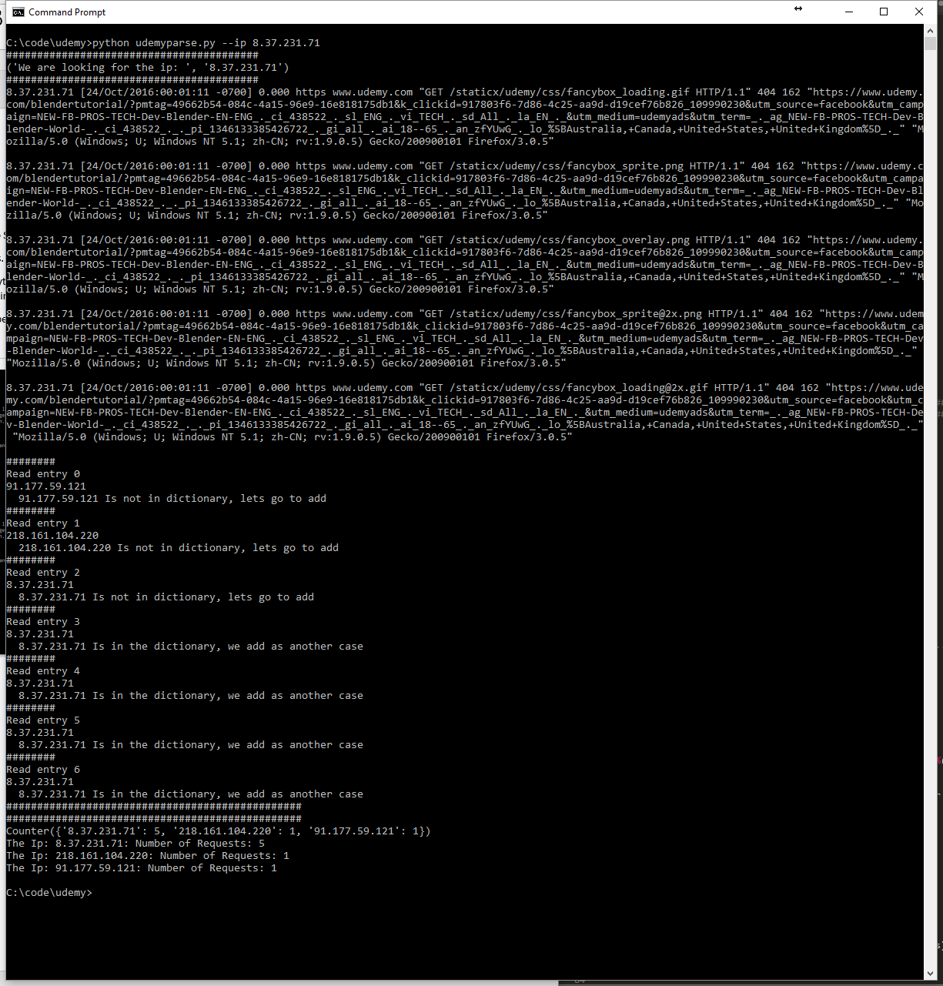

Second, udemyparse.py --topips or udemyparse.py –t x

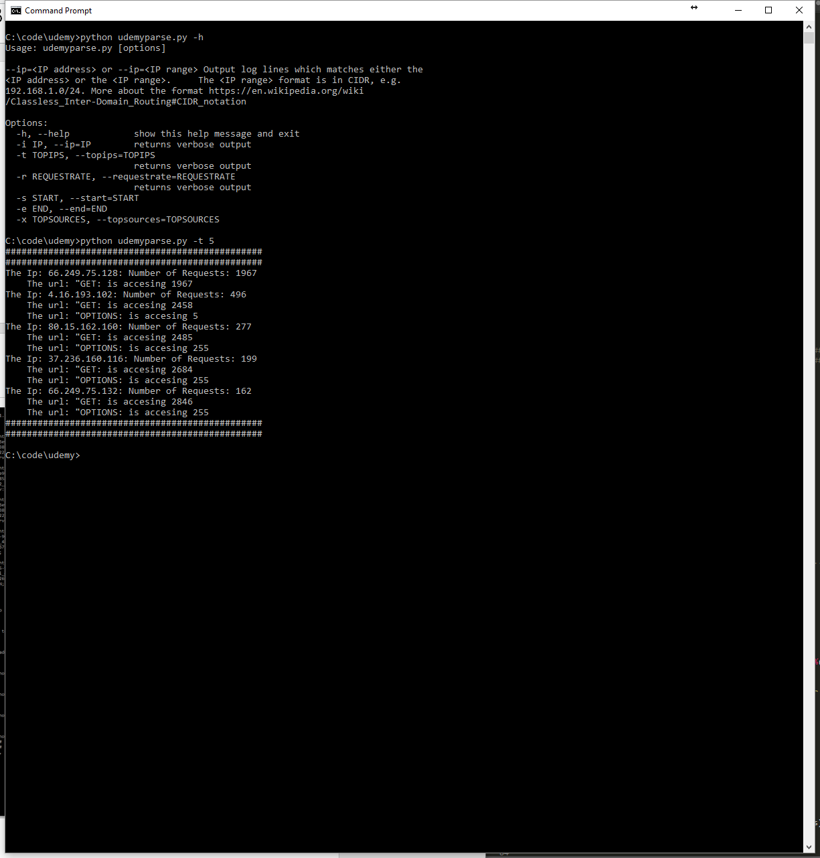

Mixing some questions, top ips and whois query:

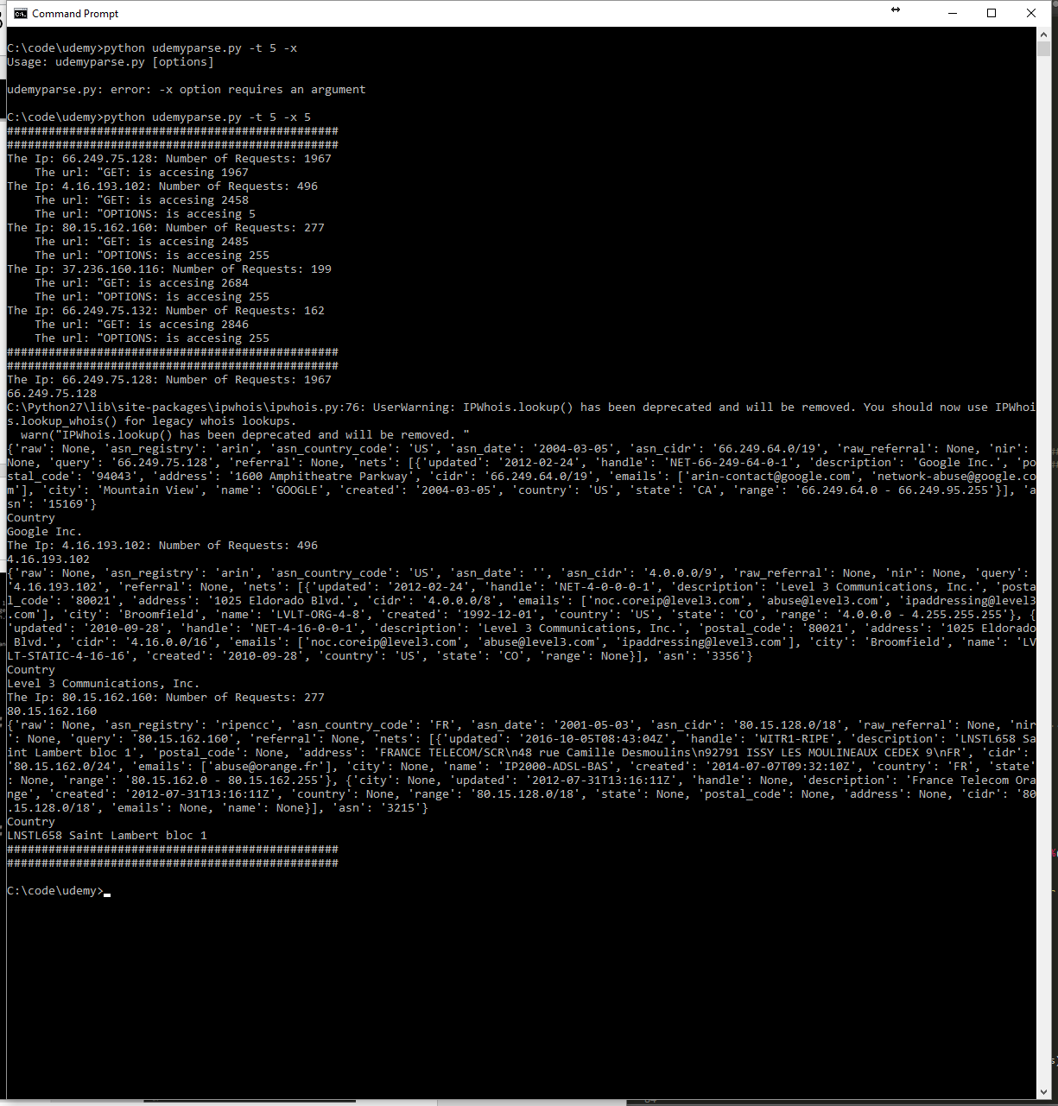

Third question, udemyparse.py –r or udemyparse.py -- requestrate

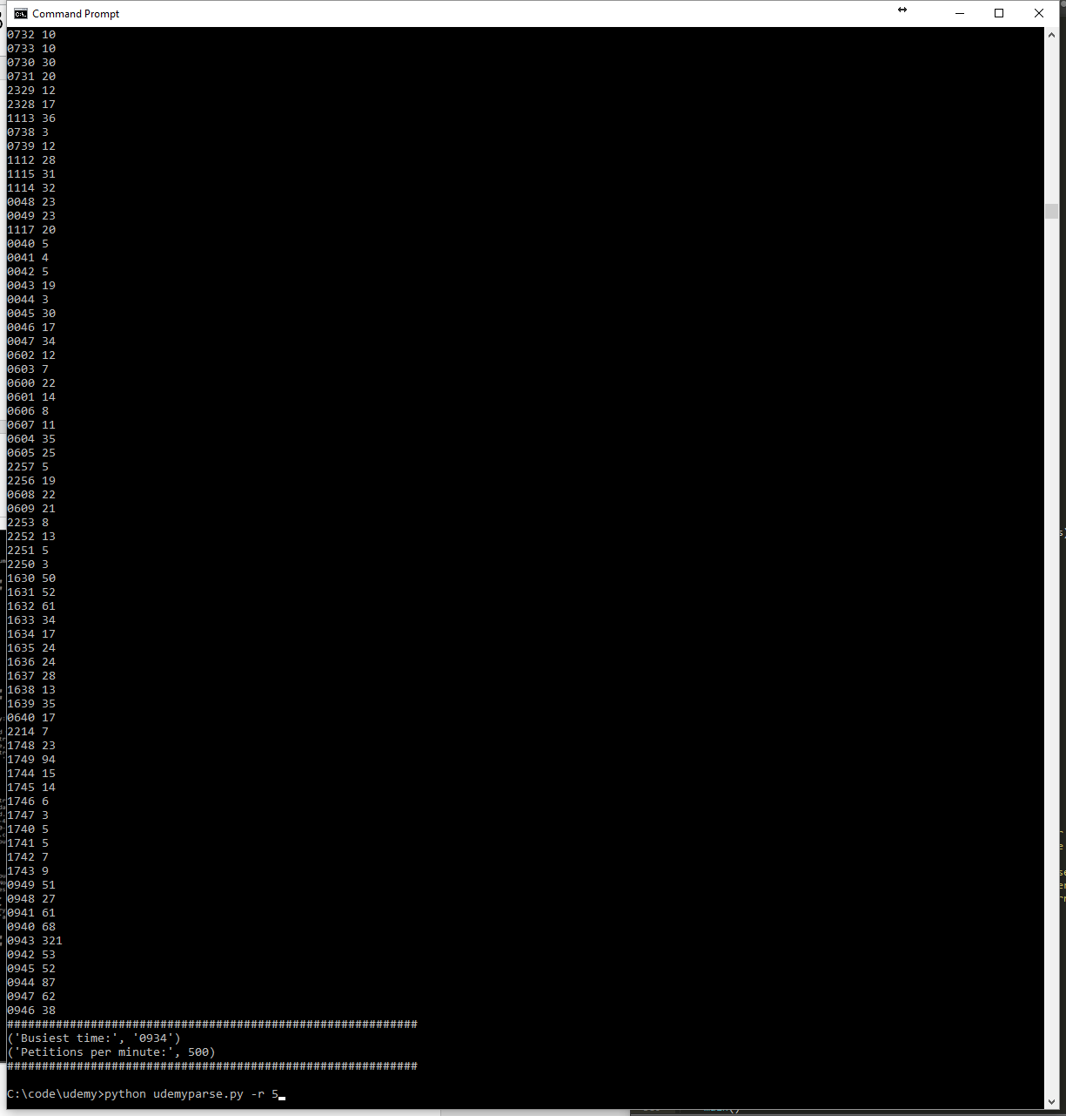

Fourth, from a start time:

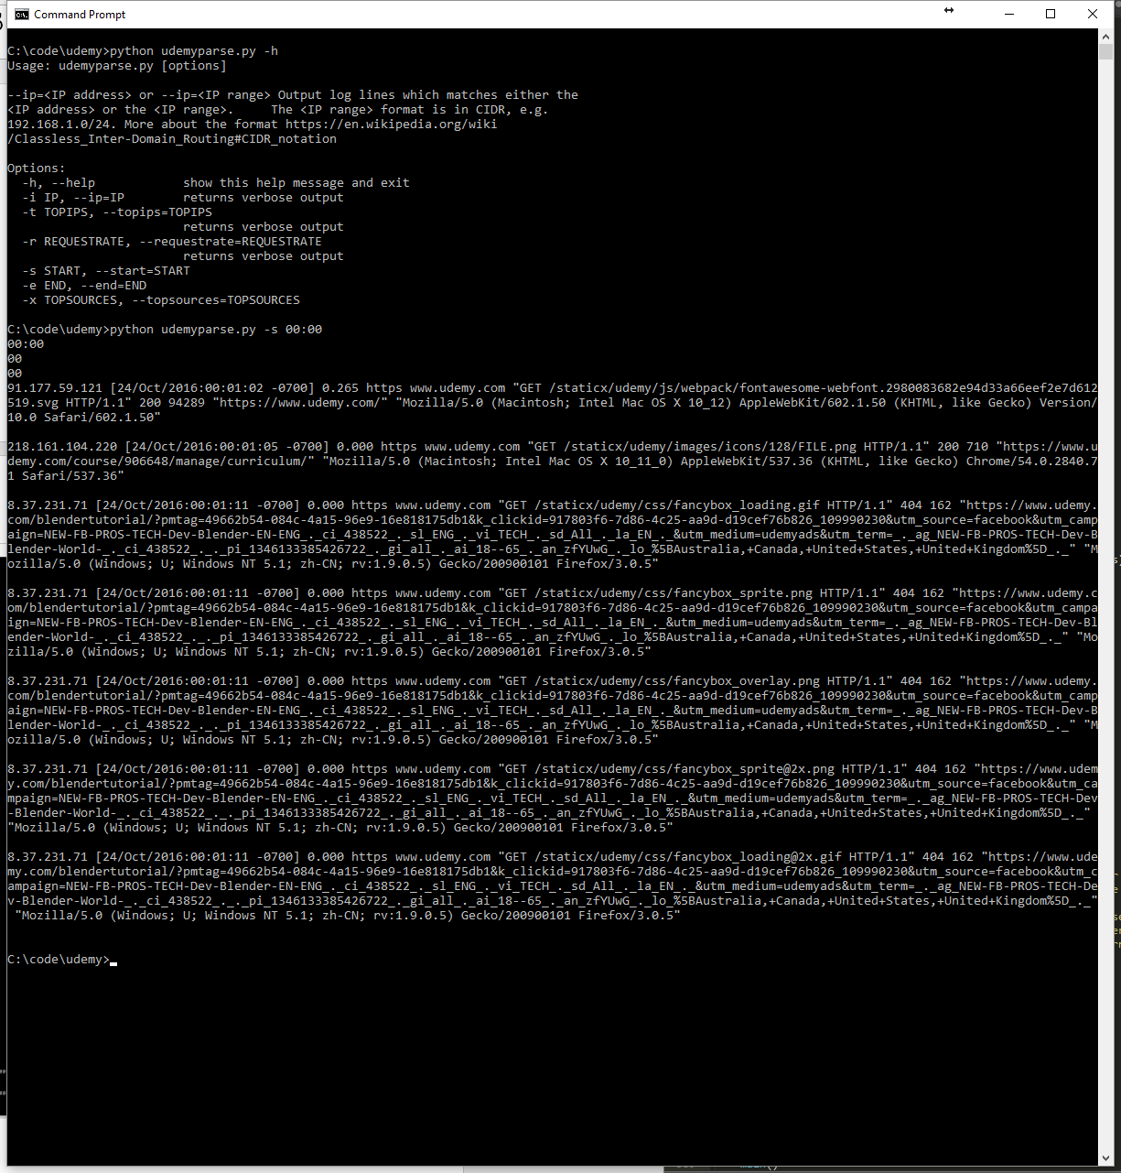

Fourth, to an end time:

